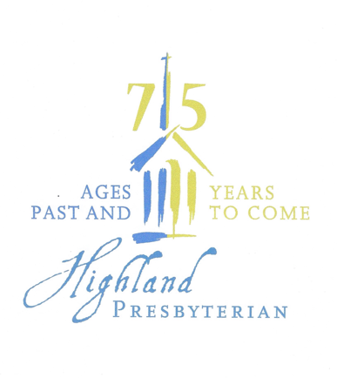 **Highland’s History – Quiz 1**

1. In what year did the steeple fall?
2. Name the restaurant where charter members met while the church was under construction.
3. What group proposed the establishment of a new church in Ardmore?
4. How much did the church spend on the original educational building and sanctuary?
5. When was the first worship service in the newly

constructed sanctuary?  Where?

**Highland’s History – Quiz 2**

1. In what year did HPC hold its first all-church retreat at Montreat?
2. Who were the two dedicated women who came to the church every Wednesday morning to prepare, cook, and serve the “Highland Fling” meals for the congregation?
3. How did the church dispose of garbage after our Fling meals>
4. Who was the first volunteer Choir Director?
5. Name three former ministers of Highland. Which one had a child who is currently a member of the church?

Suggest a Trivia Question

Do you know an interesting fact or tidbit from Highland’s past or current history?

Please share it as we continue to build upon our past and grow into the future.